**GCP PROJECT TASK**

**1.First u have to make account in google cloud plateform.**

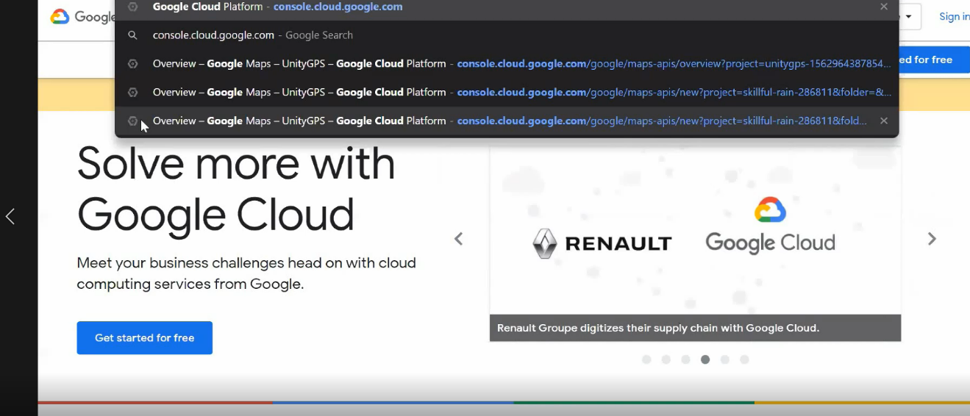

**2.Second you have to purchase the credits for billing.**

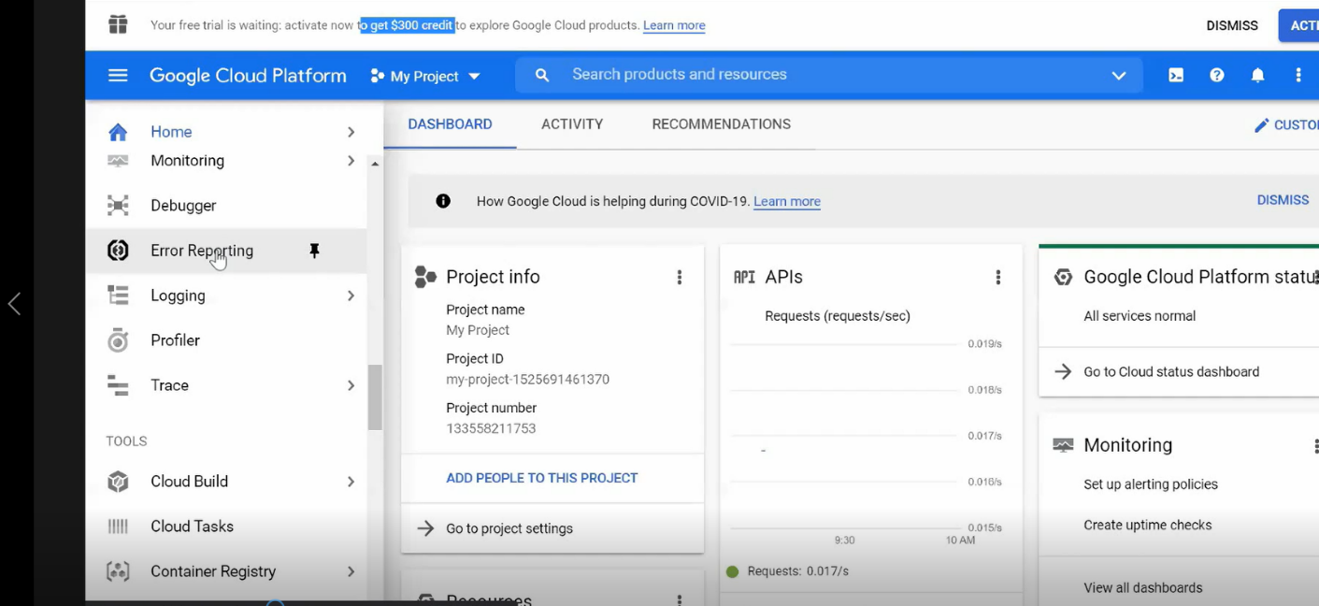

variable GCP_dev_proj1 {

default = "dev-proj-7981"

}

variable GCP_prod_proj2 {

default = "prod-proj-7981"

}

resource "google_compute_network" "vpc_prodnetwork" {

name = "vpc_network1"

project = var.GCP_prod_proj2

routing_mode = "GLOBAL"

auto_create_subnetworks = false

}

**3.Then for any compute engine you have to enable the api.**

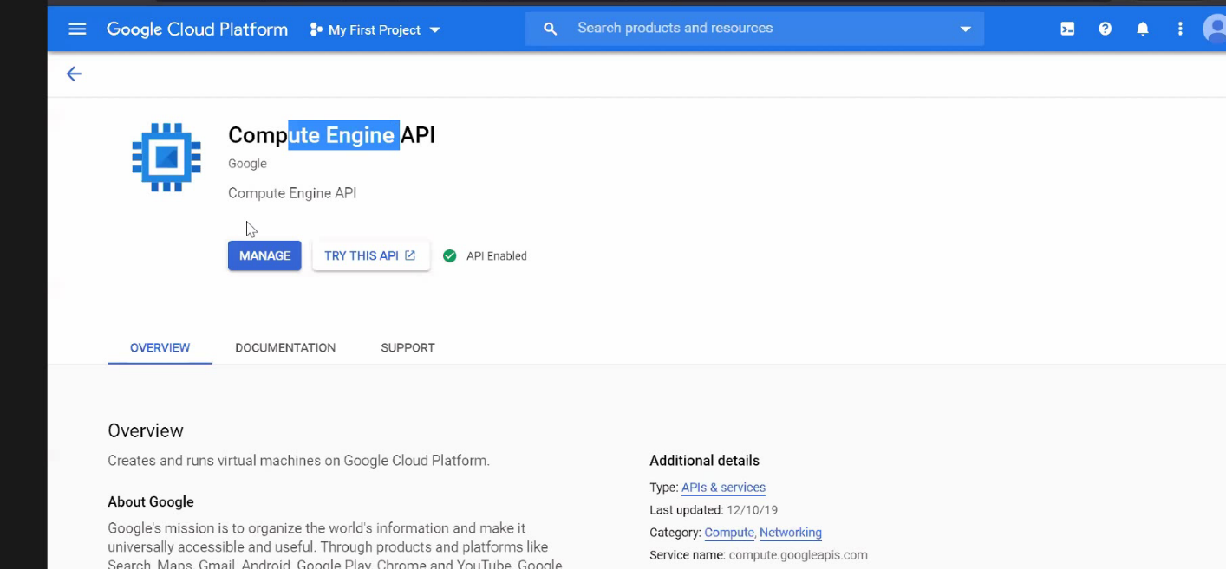

**4.Then we create the one devproject and one prodproject with enabled billing.So we can create the instances easily.**

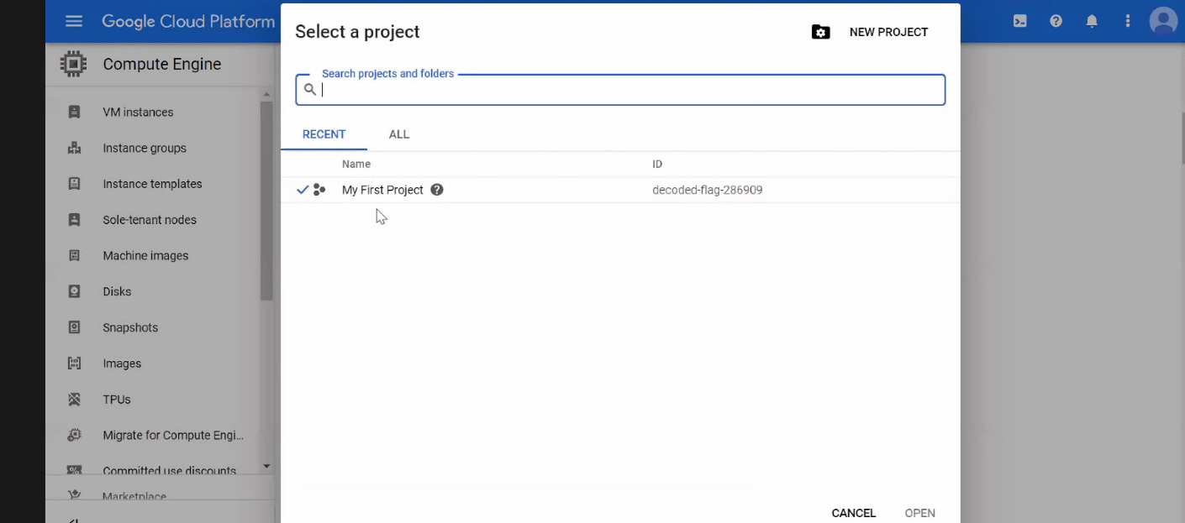

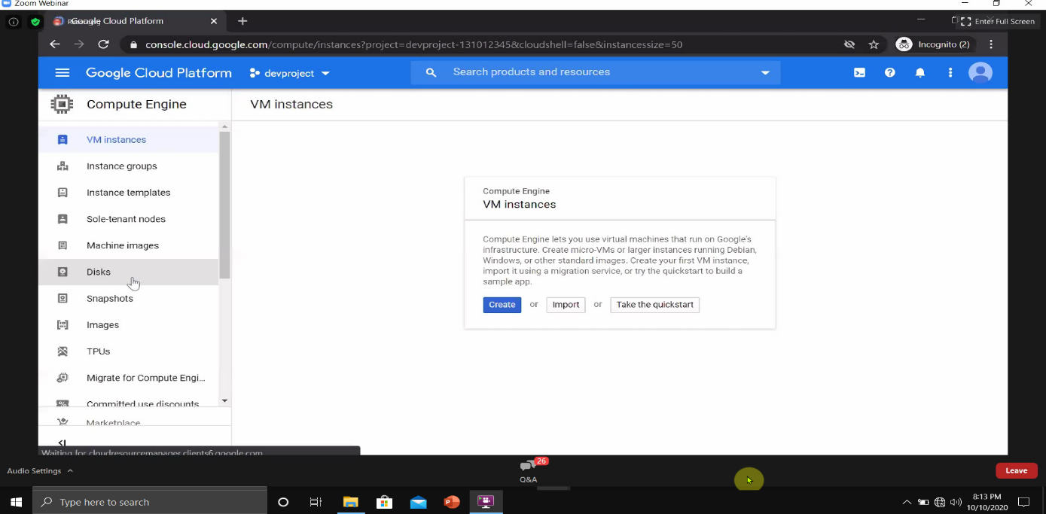

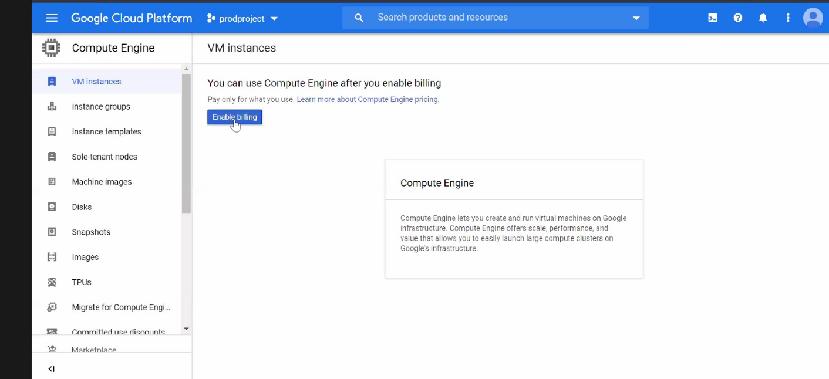

**5.Then we create the instance to launch the os.**

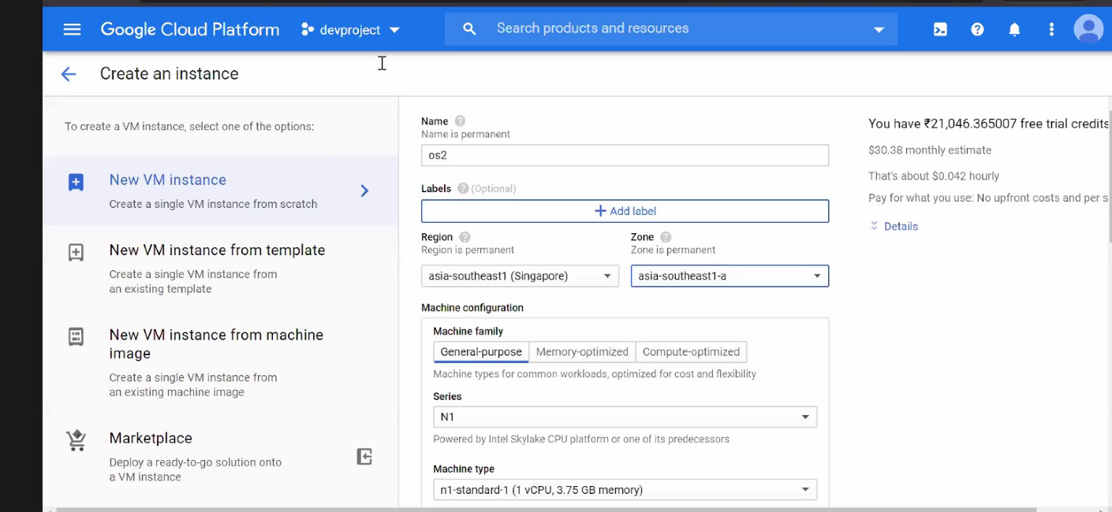

**6.Then we creating the vpc network for subnet.**

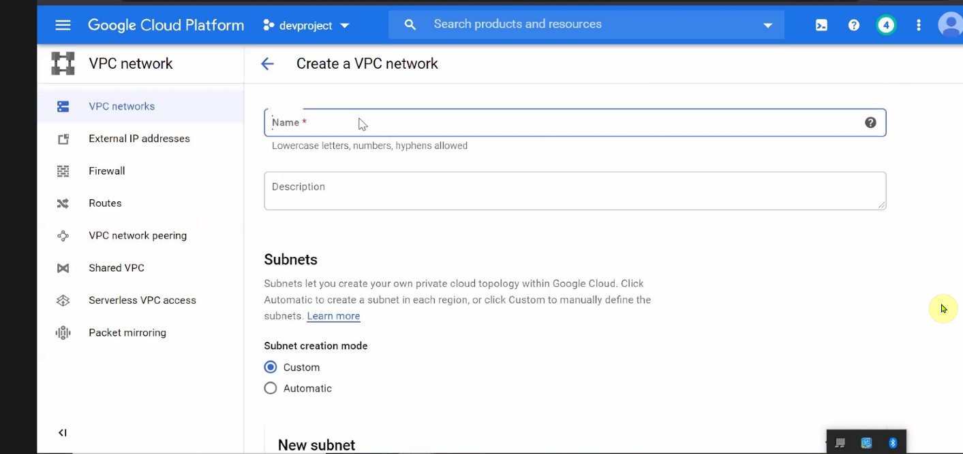

**7.Then we create firewall rule so that anyone can connect to anywhere to our os.**

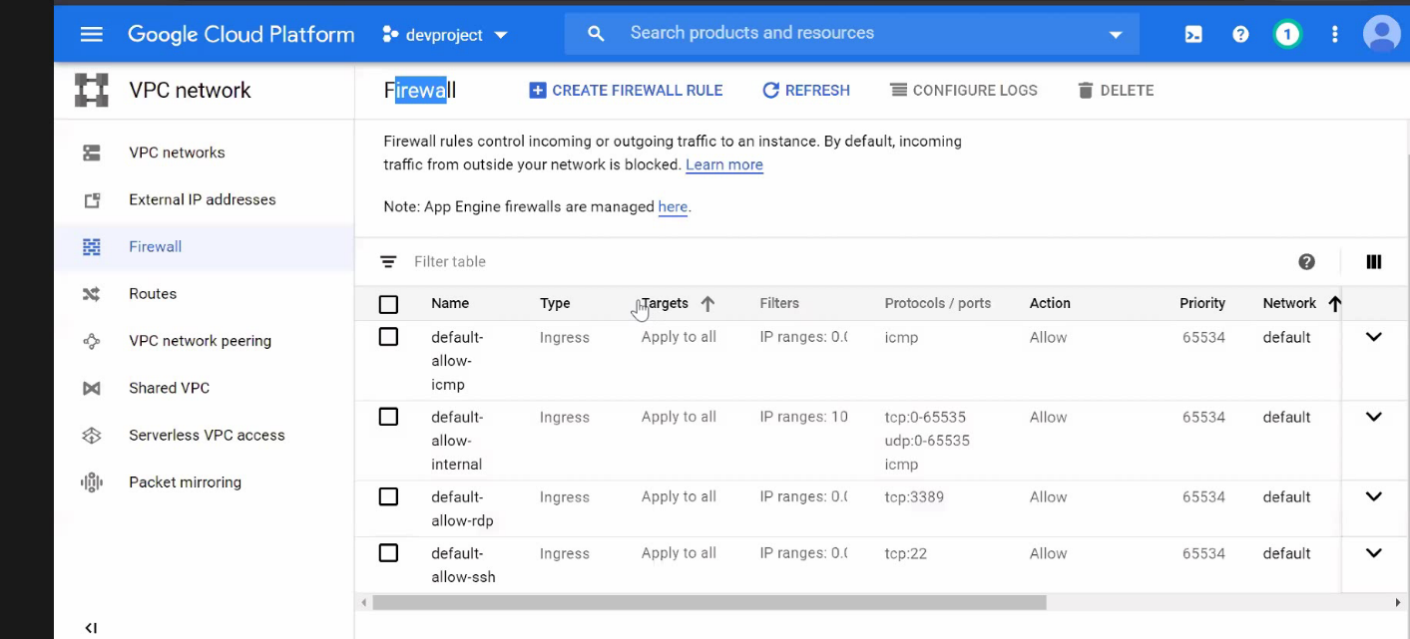

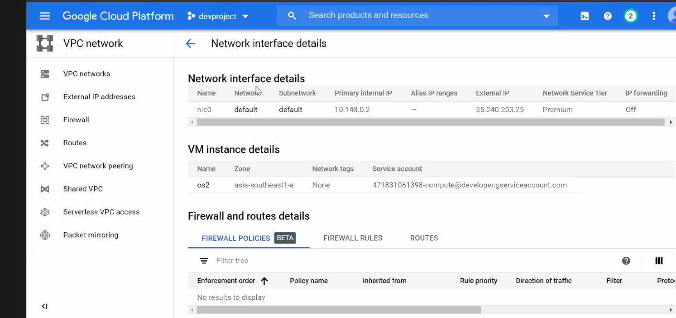**8.Then we create the vpc network card.**

**9.Then we peering the vpc network for both the project.**

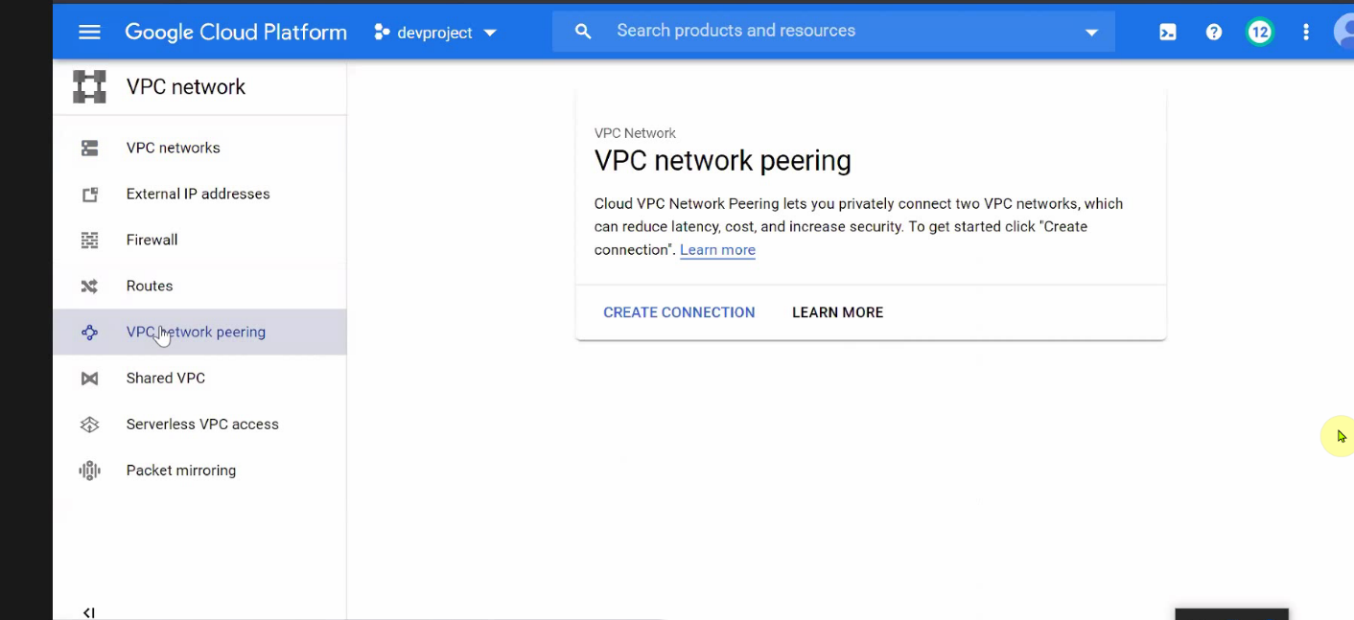

**10.Then we create the Kubernetes cluster for dev-project.**

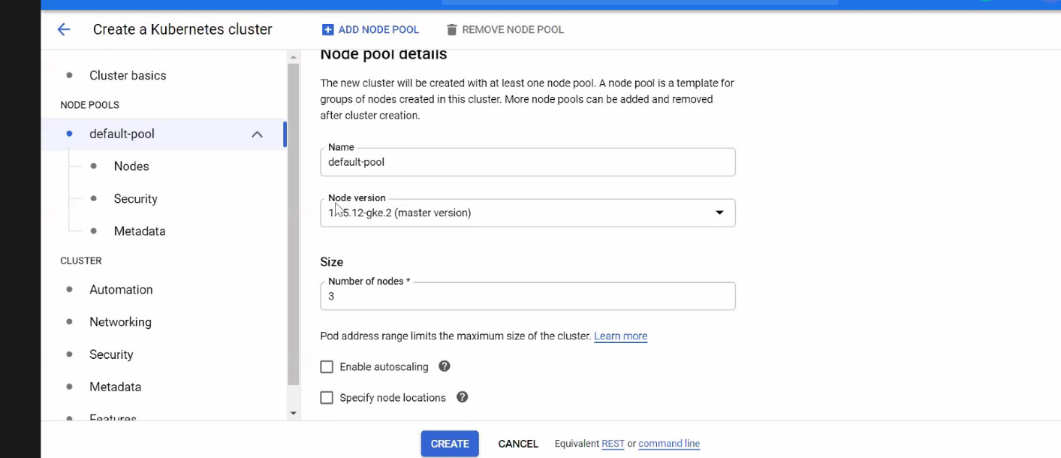

**11.Then we apply load balancing because of network traffic.**

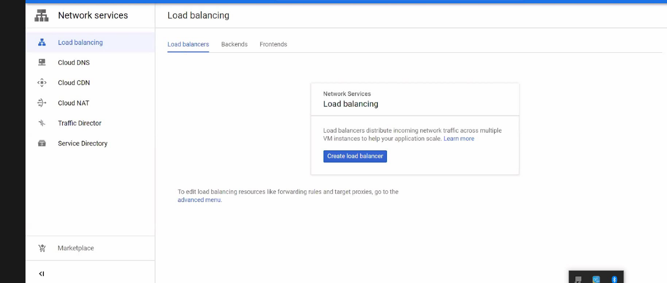

**12.Then we create the database for prod-project.**

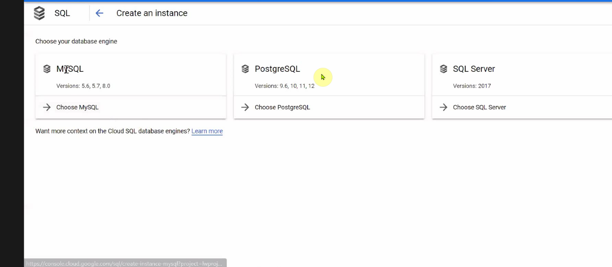

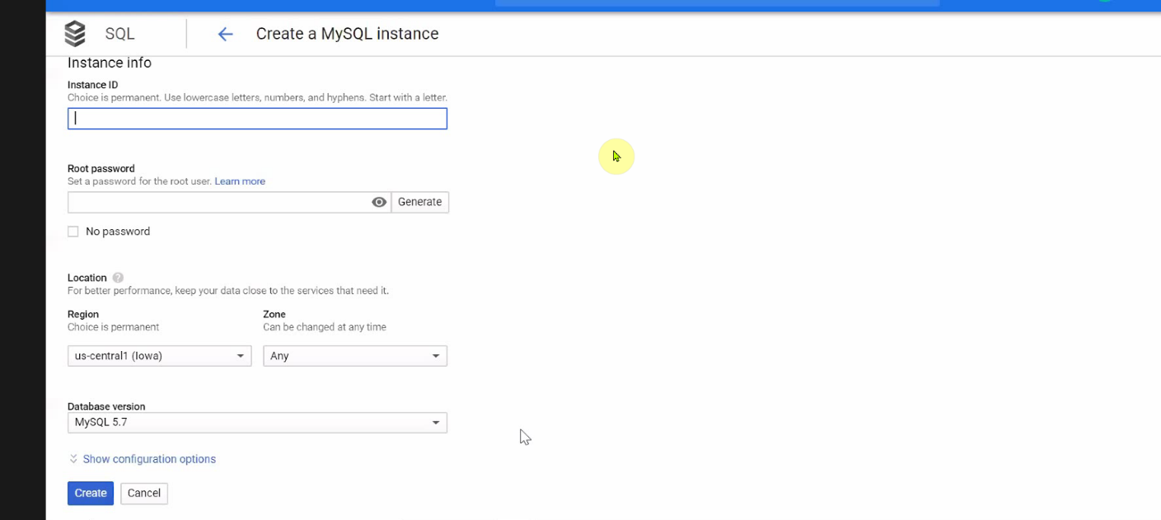

**13.Then we edit the mysql configuration.**

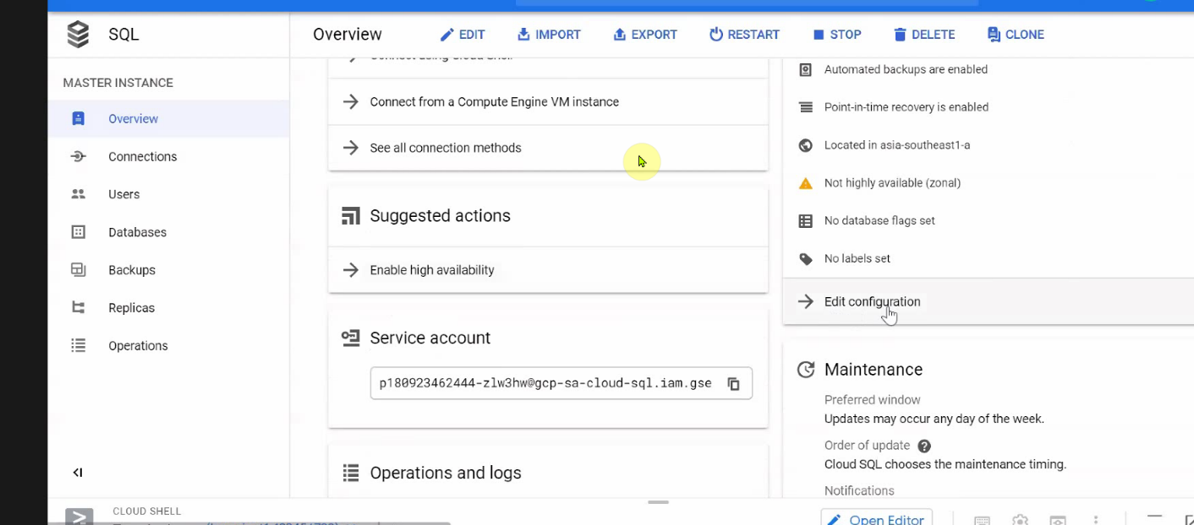

**14.At last we attach the image iso of wordpress to our sql so that we easily launch our website through webserver and then connect this mysql to Kubernetes engine in dev-project.**

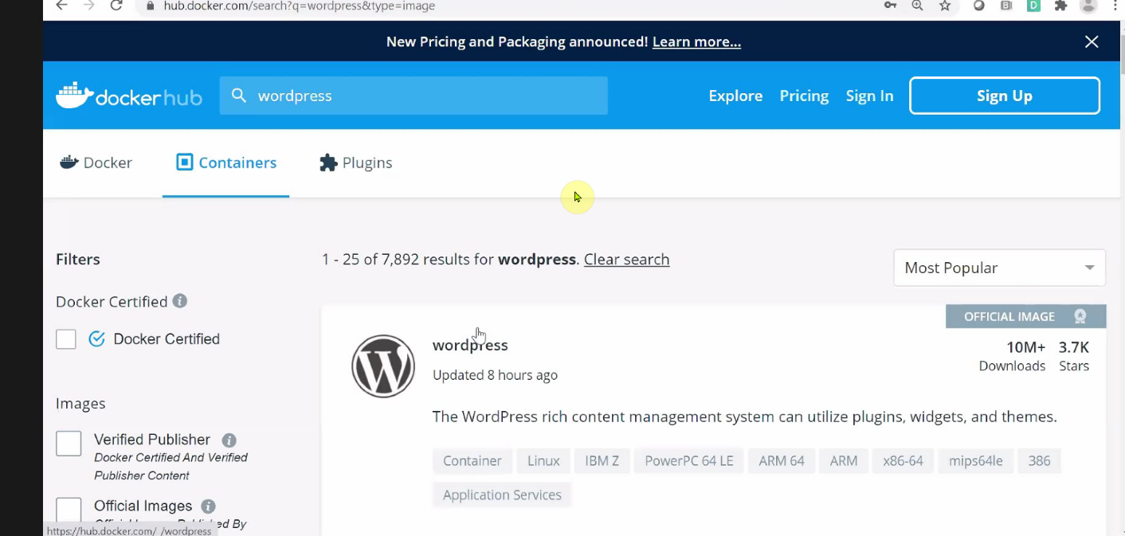

**Here are the process of doing task.**

**variable devproject {**

**default = "dev-proj-7981"**

**}**

**variable prodproject {**

**default = "prod-proj-7981"**

**}**

**resource "google_compute_network" "vpc_prodnetwork" {**

**name = "vpc_network1"**

**project = var.prodproject**

**routing_mode = "GLOBAL"**

**auto_create_subnetworks = false**

**}**

**resource "google_compute_network" "vpc_devnetwork" {**

**name = "vpc_network2"**

**project = var.devproject**

**routing_mode = "GLOBAL"**

**auto_create_subnetworks = false**

**}**

**resource "google_compute_subnetwork" "dev-subnetwork" {**

**name = "mysubnet-2"**

**ip_cidr_range = "10.10.13.0/24"**

**region = "us-west1"**

**network = "${google_compute_network.vpc_devnetwork.name}"**

**project = var.devproject**

**}**

**resource "google_compute_subnetwork" "prod-subnetwork" {**

**name = "mysubnet-2"**

**ip_cidr_range = "10.10.12.0/24"**

**region = "us-west1"**

**network = "${google_compute_network.vpc_prodnetwork.name}"**

**project = var.prodproject**

**}**

**resource "google_compute_firewall" "prod_firewall" {**

**name = "firewall-prod"**

**network = "${google_compute_network.vpc_prodnetwork.name}"**

**project = var.prodproject**

**allow {**

**protocol = "icmp"**

**}**

**allow {**

**protocol = "tcp"**

**ports = ["80", "8080", "1000-2000","22"]**

**}**

**source_tags = ["web"]**

**source_ranges = ["0.0.0.0/0"]**

**}**

**resource "google_compute_firewall" "dev_firewall" {**

**name = "firewall-dev"**

**network = "${google_compute_network.vpc_devnetwork.name}"**

**project = var.devproject**

**allow {**

**protocol = "icmp"**

**}**

**allow {**

**protocol = "tcp"**

**ports = ["80", "8080", "1000-2000","22"]**

**}**

**source_tags = ["web"]**

**source_ranges = ["0.0.0.0/0"]**

**}**

**resource "google_compute_network_peering" "peering1" {**

**name = "peering1"**

**network = "${google_compute_network.vpc_prodnetwork.id}"**

**peer_network = "${google_compute_network.vpc_devnetwork.id}"**

**}**

**resource "google_compute_network_peering" "peering2" {**

**name = "peering1"**

**network = "${google_compute_network.vpc_devnetwork.id}"**

**peer_network = "${google_compute_network.vpc_prodnetwork.id}"**

**}**

**resource "google_compute_instance" "prod" {**

**name = "test"**

**machine_type = "n1-standard-1"**

**zone = "us-west1-c"**

**project = var.prodproject**

**tags = ["foo", "bar"]**

**boot_disk {**

**initialize_params {**

**image = "debian-cloud/debian-9"**

**}**

**}**

**network_interface {**

**network = "${google_compute_network.vpc_prodnetwork.name}"**

**subnetwork = "${google_compute_subnetwork.prod-subnetwork.name}"**

**subnetwork_project = "prod-proj-7981"**

**access_config {**

**}**

**}**

**}**

**resource "google_compute_instance" "dev" {**

**name = "test1"**

**machine_type = "n1-standard-1"**

**zone = "us-west1-c"**

**project = var.devproject**

**tags = ["foo", "bar"]**

**boot_disk {**

**initialize_params {**

**image = "debian-cloud/debian-9"**

**}**

**}**

**network_interface {**

**network = "${google_compute_network.vpc_devnetwork.name}"**

**subnetwork = "${google_compute_subnetwork.dev-subnetwork.name}"**

**subnetwork_project = "dev-proj-7981"**

**access_config {**

**}**

**}**

**}**

**resource "google_container_cluster" "primary" {**

**name = "marcellus-wallace"**

**location = "us-central1-a"**

**initial_node_count = 3**

**project = "dev-proj-7981"**

**master_auth {**

**username = "username"**

**password = "pass"**

**client_certificate_config {**

**issue_client_certificate = false**

**}**

**}**

**node_config {**

**oauth_scopes = [**

**"https://www.googleapis.com/auth/logging.write",**

**"https://www.googleapis.com/auth/monitoring",**

**]**

**metadata = {**

**disable-legacy-endpoints = "true"**

**}**

**labels = {**

**app = "wordpress"**

**}**

**tags = ["website", "wordpress"]**

**}**

**timeouts {**

**create = "30m"**

**update = "40m"**

**}**

**}**

**resource "null_resource" "nullremote1" {**

**depends_on = [google_container_cluster.primary]**

**provisioner "local-exec" {**

**command = "gcloud container clusters get-credentials ${google_container_cluster.primary.name} --zone ${google_container_cluster.primary.location} --project ${google_container_cluster.primary.project}"**

**}**

**}**

**resource "kubernetes_service" "example" {**

**depends_on = [null_resource.nullremote1]**

**metadata {**

**name = "loadbalancer"**

**}**

**spec {**

**selector = {**

**app = "${kubernetes_pod.example.metadata.0.labels.app}"**

**}**

**session_affinity = "ClientIP"**

**port {**

**port = 80**

**target_port = 80**

**}**

**type = "LoadBalancer"**

**}**

**}**

**resource "kubernetes_pod" "example" {**

**metadata {**

**name = "terraform-example"**

**labels = {**

**app = "MyApp"**

**}**

**}**

**spec {**

**container {**

**image = "wordpress:4.8-apache"**

**name = "mywp"**

**}**

**}**

**}**

**output "wordpressip" {**

**value = kubernetes_service.example.load_balancer_ingress**

**}**

**resource "google_sql_database" "database" {**

**name = "my-database1"**

**instance = google_sql_database_instance.instance.name**

**project = "prod-proj-7981"**

**}**

**resource "google_sql_database_instance" "instance" {**

**name = "my-database-instance54"**

**database_version = "MYSQL_5_6"**

**region = "us-central1"**

**project = "prod-proj-7981"**

**settings {**

**tier = "db-f1-micro"**

**ip_configuration {**

**ipv4_enabled = true**

**authorized_networks {**

**name = "public network"**

**value = "0.0.0.0/0"**

**}**

**}**

**}**

**}**

**resource "google_sql_user" "users" {**

**name = "yogesh"**

**instance = google_sql_database_instance.instance.name**

**project = "prod-proj-7981"**

**password = "redhat"**

**}**